**Module-3: Docker – I Assignment – 4**

1. Create a Dockerfile with the following specs:

● Ubuntu container

● Apache2 installed

● Apache2 should automatically run once the container starts

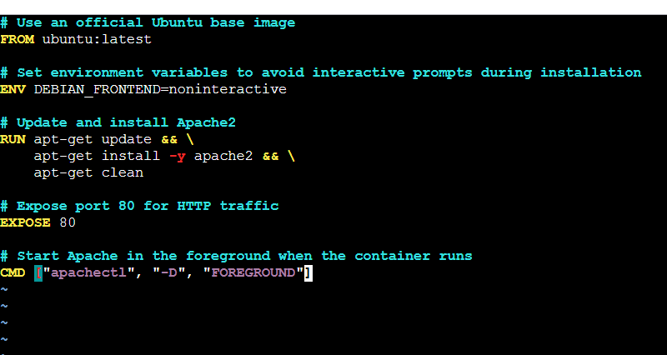

# Use an official Ubuntu base image

FROM ubuntu:latest

# Set environment variables to avoid interactive prompts during installation

ENV DEBIAN_FRONTEND=noninteractive

# Update and install Apache2

RUN apt-get update && \

apt-get install -y apache2 && \

apt-get clean

# Expose port 80 for HTTP traffic

EXPOSE 80

# Start Apache in the foreground when the container runs

CMD ["apachectl", "-D", "FOREGROUND"]

2. Submit the Dockerfile for assignment completion

